2018
5. (a)What is cell relay? Is cell relay essential for real time multimedia transmission? 2.25
Cell relay is a network technology for data transmission that uses small data packets of a fixed size called cells. Cells are the basic units of data, and are widely used in common networks for communication. Just like frames, which are data packets of variable size, cells travel from one computer to another over a network. Asynchronous transfer mode (ATM) is a particularly popular form of cell relay, and is based on cell units.
The cell relay is considered by most to be the transport service of the future. High-speed Transmission The purpose of ATM is to provide high speed and low-delay switching networks to support any type of user traffic, such as voice, data or video applications.
(b) Describe the ATM cell structure. 4
ATM standard is widely accepted by common carriers as mode of operation for communication.
ATM is a form of cell switching using small fixed-sized packets.
ATM Conceptual Model Four Assumptions
ATM network will be organized as a hierarchy.
User’s equipment connects to networks via a UNI (User-Network Interface).
Connections between provided networks are made through NNI (Network-Network Interface).
ATM will be connection-oriented.
Vast majority of ATM networks will run on optical fiber networks with extremely low error rates.
ATM must support low cost attachments.
ATM Connections
two levels of ATM connections:
virtual path connections
virtual channel connections
indicated by two fields in the cell header:
virtual path identifier VPI
virtual channel identifier VCI
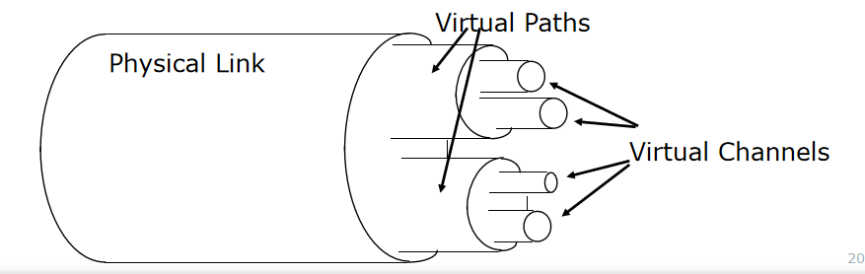
ATM Cell Format
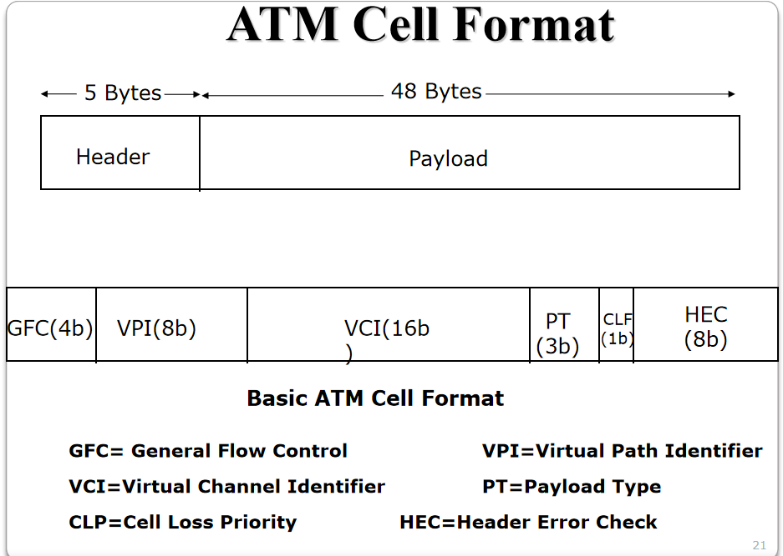
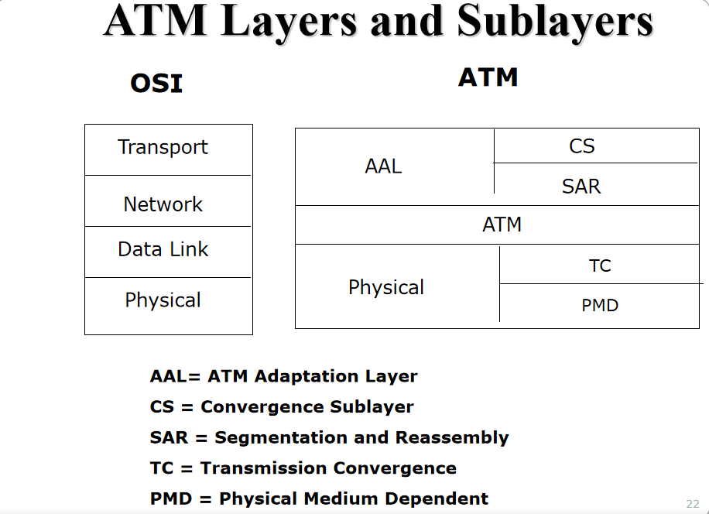

(c)Mention the multimedia service classes in multimedia network communication. 2.5
Quality of Service
Provide guarantees on the ability of a network to deliver predictable results.
Elements of network performance within the scope of QoS often include availability (uptime), bandwidth (throughput), latency (delay), and error rate.
Multimedia Traffic Parameters
peak arrival rate of the multimedia data when the source is in the active state(peak rate);
average data unit arrival rate;
burstiness: ratio between the peak data rate and the average data rate;
average duration of the active state.
Quality of Service Parameter
Data Rate
Latency
Packet loss or error
Jitter
Sync skew
QoS Classes:
Guaranteed Service Class
QoS guarantees are provided based on deterministic and statistical QoS parameters
Predictive Service Class
QoS parameter values are estimated and based on the past behavior of the service
Best Effort Service Class
There are no guarantees or only partial guarantees are provided

6(a) What is multimedia operating system? 1
Operating systems handle general data, like text files, programs, binary files, word-processing documents and also spreadsheets. ... Multimedia kind of data consists of continuous media in the form of files (audio or video) data as well as conventional files to run.
©When does RMS scheduling fail? 1
RMS only works if the CPU utilization is not too high. Liu and Layland proved that for any system of periodic processes, if
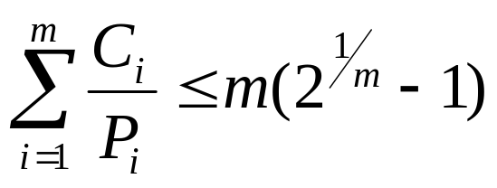
then RMS is guaranteed to work.
Assumes fixed amount of processing per periodic task.
For 3, 4, 5, 10, 20, and 100, the maximum permitted utilization are 0.78, 0.757, 0.743, 0.718, 0.705, and 0.696.

7(a) List three distinct models of color used in multimedia. Explain why there are a number of different color models exploited in multimedia data formats. 5.75
Possible models:
•RGB
•CIE Chromaticity
•YIQ Colour Space
•YUV (YCrCb)
•CMY/CMYK
Different models reflect need to represent colour in a perceptually relevant model for effective compression.
Different models also due to evolution of colour from Video (YIQ,YUV), Display (RGB) and Print (CMYK) media requirements
(b) Explain different types of video signal. 3
Video signals can be organized in three different ways: Component video, Composite video, and S - video.
- Component video
  - Three separate signals for tristimulus color representation or luminance-chrominance representation
  - Pro: higher quality, no cross talk
  - Con: need high bandwidth and synchronization
- Composite video
  - Multiplex into a signal
  - Historical reason for transmitting color TV through monochrome channel
  - Pro: save bandwidth
  - Con: cross talk
- S-video: luminance sig. + single multiplexed chrominance sig.
  - Pro: less color detail
  - Con: cross talk

8(a)”RTP runs over UDP” .Explain the design issue of RTP in multimedia transmission. 5.75
- RTP specifies packet structure for packets carrying audio, video data
- RTP packet provides
payload type identification
packet sequence numbering
time stamping
- RTP runs in end systems
- RTP packets encapsulated in UDP segments
- interoperability: if two Internet phone applications run RTP, then they may be able to work together
RTP runs on top of UDP
RTP libraries provide transport-layer interface that extends UDP
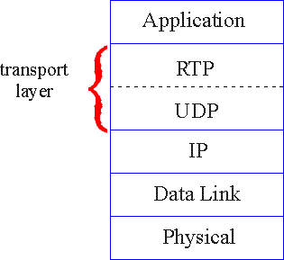
RTP Example
- consider sending 64 kbps PCM-encoded voice over RTP.
- application collects encoded data in chunks, e.g., every 20 msec = 160 bytes in a chunk.
- audio chunk + RTP header form RTP packet, which is encapsulated in UDP segment
- RTP header indicates type of audio encoding in each packet
- RTP header also contains sequence numbers, timestamps.
RTP and QoS
- RTP does not provide any mechanism to ensure timely data delivery or other QoS guarantees.
- RTP encapsulation is only seen at end systems (not) by intermediate routers.
routers providing best-effort service, making no special effort to ensure that RTP packets arrive at destination in timely matter.
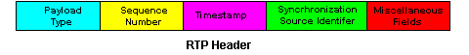
Payload Type (7 bits): Indicates type of encoding currently being used.
Sequence Number (16 bits): Increments by one for each RTP packet sent, and used to detect packet loss and to restore packet sequence.
Timestamp (32 bytes long): The timestamp records the first octet of the packet is sampled; it is set by the sender.
Synchronization Source (SSRC 32 bits long): Identifies source of RTP stream. Each stream in RTP session should have distinct SSRC.
Contributing Source (CSRC 32 bits long): Identifies source of contributors.
(b)Which type of frame is used in MPEG video? Discuss about them. 3
I-frame
Short for intraframe, a video compression method used by the MPEG standard.
An I-frame is a single frame of digital content that the compressor examines independent of the frames that precede and follow it and stores all of the data needed to display that frame.
A I-frames are interspersed with P-frames and B-frames in a compressed video.
The more I-frames that are contained, the better quality the video will be; however, I-frames contain the most amount of bits and therefore take up more space on the storage medium.
P-frame
Short for predictive frame, or predicted frame, a video compression method used by the MPEG standard.
P-frames follow I-frames and contain only the data that have changed from the preceding I-frame (such as color or content changes).
P-frames depend on the I-frames to fill in most of the data.
B-frame
Short for bi-directional frame, or bi-directional predictive frame, a video compression method used by the MPEG standard.
B-frames rely on the frames preceding and following them.
B-frames contain only the data that have changed from the preceding frame or are different from the data in the very next frame.
2017
5(a) Discuss the characteristics of multimedia OS. 3.00
A Multimedia system has four basic characteristics:
- Multimedia systems must be computer controlled.
- Multimedia systems are integrated.
- The information they handle must be represented digitally.
- The interface to the final presentation of media is usually interactive.

(b) Distinguish between traditional file system and multimedia file system. 2.00
Traditional OS
requests for disk blocks is unpredictable
one-block read ahead for each file to increase performance
other than that, wait for requests to come in and process them on demand
Multimedia OS
each active stream puts a well defined load on the system that is highly predictable (for PAL, a frame is needed every 40 msec)

©Why real time scheduling is necessary in multimedia OS? 3.75
    - Number of users changes as viewers come and go, frame sizes vary due to compression, and different movies may have different resolutions.
    - This means several processes have to run at different frequencies, with different amount of work, and with different deadlines.
6(a) Briefly discuss the parameters measured in quality of services for multimedia data transmission. 3.5
Quality of Service (QoS)
Quality of Service (QoS) for multimedia data transmission depends on many parameters. Some of the most important are:
- Data Rate. A measure of transmission speed, often in kilobits per second (kbps) or megabits per second (Mbps)

- Latency (maximum frame/packet delay). Maximum time needed from transmission to reception, often measured in milliseconds (msec). In voice communication, for example, when the round - trip delay exceeds 50 msec, echo becomes a noticeable problem; when the one - way delay is longer than 250 msec, talker overlap will occur, since each caller will talk without knowing the other is also talking.

- Packet loss or error. A measure (in percentage) of error rate of the packetized data transmission. Packets get lost or garbled, such as over the Internet. They may also be delivered late or in the wrong order. Since retransmission is often undesirable, a simple error - recovery method for real - time multimedia is to replay the last packet, hoping the error is not noticeable.

FIGURE 16.1: Jitters in frame playback: (a) high jitter; (b) low jitter
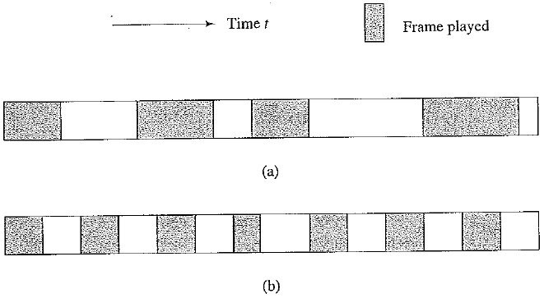
In general, for uncompressed audio / video, the desirable packet loss is < 10 - 2 (lose every hundredth packet, on average). When it approaches 10%, it becomes intolerable. For compressed multimedia and ordinary data, the desirable packet loss is less than 10 - 7 to 10 - 8.
- Jitter (or delay jitter). A measure of smoothness of the audio / video playback. Technically, jitter is related to the variance of frame / packet delays. A large buffer (jitter buffer) can to hold enough frames to allow the frame with the longest delay to arrive, to reduce playback jitter. However, this increases the latency and may not be desirable in real - time and interactive applications. The above figure illustrates examples of high and low jitters in frame playbacks.

- Sync skew. A measure of multimedia data synchronization, often measured in milliseconds (msec). For a good lip synchronization, the limit of sync skew is ±80 msec between audio and video. In general, ±200 msec is still acceptable. For a video with speaker and voice the limit of sync skew is 120 msec if video precedes voice and 20 msec if voice precedes video. (The discrepancy is probably because we are used to have sound lagging image at a distance.)

(b)Write the advantages of internet telephony over plain old telephone services. 2.5
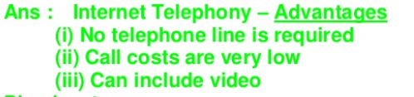
Benefits of internet telephony
1. Low cost - The main benefit of internet telephony is the low cost. PC-to-PC calls are generally free, and PC-to-Phone connections are generally a fraction of the cost of a traditional phone line.
2. Portability – One only needs a laptop and an internet connection to use Internet telephony, whether in an airport, a library, or a fast-food restaurant.
3. Internet telephony also offers a wide range of features and services that are not found on traditional landline phone. Just a few of these amazing features are text voicemail, video voicemail, and voicemail to email, call parking, and the busy line feature.
4. Scalable: The software oriented nature of IP telephony makes it easily scalable, making it possible to integrate other services and applications as well. Adding a new phone to the already running system of IP telephony doesn't require an additional new line. It can be directly incorporated in the system, within the existing infrastructure, which is not in the case of traditional phones.
5. Toll-Free Access: While US toll-free numbers are generally not accessible from outside the US, Internet calling enables users to reach toll-free numbers from anywhere in the world.

©Describe the SIP protocol in internet Telephony. 2.75
Session Initiation Protocol (SIP) is a signaling protocol used for initiating, maintaining, modifying and terminating real-time sessions that involve video, voice, messaging and other communications applications and services between two or more endpoints on IP networks.

SIP features
The SIP communications protocol determines five attributes when establishing and terminating multimedia sessions:
- User location.
- User availability.
- User capabilities.
- Session setup.
- Session management.
Different types of multimedia SIP sessions include internet telephony calls, video conferencing and other forms of unified communications. The protocol can be used to invite participants to unicast or multicast sessions that do not necessarily involve the initiator.

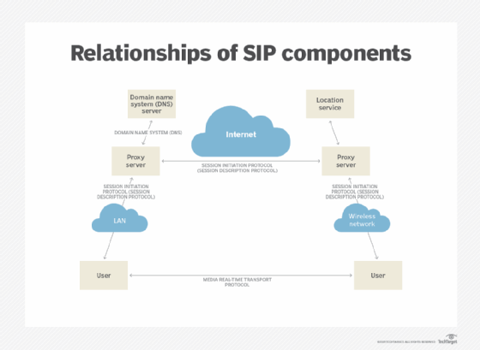
7(a) Define Pull server file system and push server system
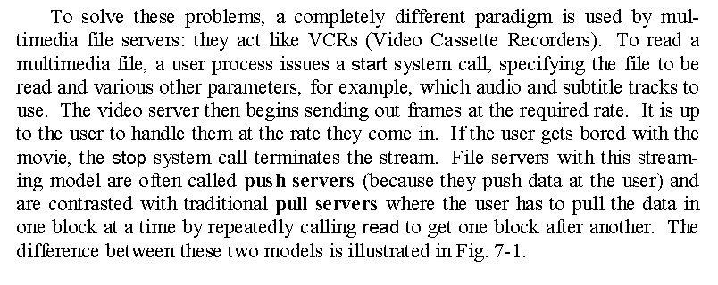
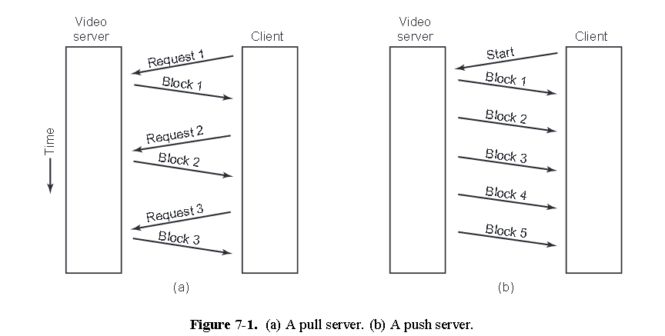
(b)Briefly discuss the different organization of placing files over multiple disks in a video server
I can’t get answer of this question from anywhere
In computing, a file server (or fileserver) is a computer attached to a network that provides a ... A dedicated server is designed specifically for use as a file server, with ... a file server is storage, technology has been developed to operate multiple disk ... organizations, authentication could take place directly at the server itself.
©Describe the scan EDF algorithm for disk scheduling in multimedia system
EDF (Earliest Deadline First Scheduling)
- EDF is dynamic algorithm that does not require
    - processes to be periodic.
    - processes to have the same run time per CPU burst.
- The scheduler keeps a list of runnable processes, sorted on deadline.
- The algorithm runs the first process on the list, the one with the closest deadline
- Whenever a new process becomes ready, the system checks to see if its deadline occurs before that of the currently running process. If so, the running process is preempted
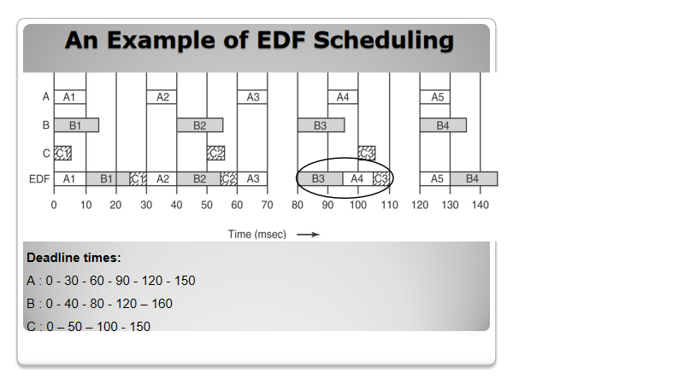
8Write short notes on
- DPCM coding
Differential Pulse Code Modulation (DPCM):
DPCM stands for Differential Pulse Code Modulation, is same as Pulse Code Modulation technique used for reworking analog signal into digital signal. Differential Pulse Code Modulation has moderate signal to noise magnitude relation. Differential Pulse Code Modulation differs from Pulse Code Modulation as a results of it quantizes the excellence of the actual sample and expected value. that’s the reason it’s cited as as differential Pulse Code Modulation(DPCM).
DPCM transmitter and DPCM receiver operations are given below through figure:

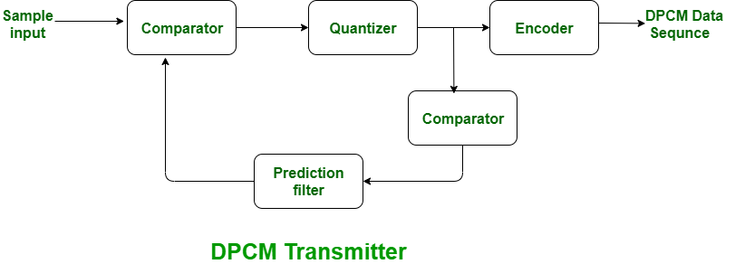
In the above diagram, if the signal is large then the next bit in digital data is 1 otherwise next bit is 0.
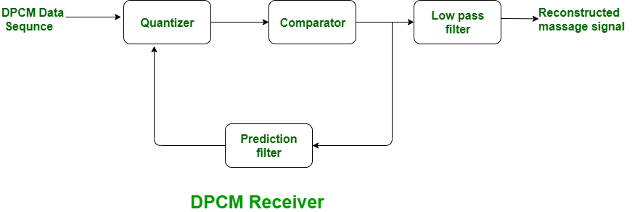

- Digital Watermarking
- A watermark is a “secret message” that is embedded into a “cover (original or host) message”.
- Only the knowledge of a secret key allows us to extract the watermark from the cover message.
- Effectiveness of a watermarking algorithm is a function of its
Resilience to attacks.
Capacity.
Stealth.
What Can Be Watermarked?
- Multimedia data.
Video.
Audio.
Still Images.
- Documents.
- Software.
- Hardware designs.
Multimedia Watermarks
- A digital watermark is a “secret key dependent” signal “inserted” into digital multimedia data.
- Watermark can be later detected/extracted in order to make an assertion about the data.
- A digital watermark can be.
Visible (perceptible).
Invisible (imperceptible).
Watermark Applications
Proof of ownership.
Copy prevention or control.
Content protection (visible watermarks).
Authentication.
Media Bridging.
Broadcast Monitoring.
Fingerprinting.
Secret Communications.
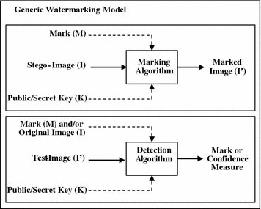
©RSVP
RSVP: Resource Reservation Protocol
“ … allow use rs to communicate requirements to network in robust and efficient way.”
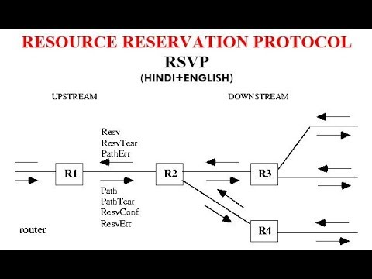
RSVP Design Goals
- accommodate heterogeneous receivers (different bandwidth along paths)
- accommodate different applications with different resource requirements
- make multicast a first class service, with adaptation to multicast group membership
- control existing multicast/unicast routing, with adaptation to changes in underlying unicast, multicast routes
- control protocol overhead to grow (at worst) linear in # receivers
- modular design for heterogeneous underlying technologies
RSVP: overview of operation
senders, receiver join a multicast group
done outside of RSVP
senders need not join group
sender-to-network signaling
path message: make sender presence known to routers
path teardown: delete sender’s path state from routers
receiver-to-network signaling
reservation message: reserve resources from sender(s) to receiver
reservation teardown: remove receiver reservations
network-to-end-system signaling
path error
reservation error
2016
5(a) What is 3D graphics? Explain how 3D graphics is useful for multimedia application.
3D computer graphics, or three-dimensional computer graphics (in contrast to 2D computer graphics), are graphics that use a three-dimensional representation of geometric data (often Cartesian) that is stored in the computer for the purposes of performing calculations and rendering 2D images. The resulting images may be stored for viewing later (possibly as an animation) or displayed in real time.
Application of Computer Graphics
Computer graphics are very useful. Today almost every computer can do some graphics, and people have even come to expect to control their computer through icons and pictures rather than just by typing.
Computer-generated imagery is used for movie making, video game and computer program development, scientific modeling, and design for catalogs and other commercial art. Some people even make computer graphics as art. We can classify applications of computer graphics into four main areas:
- Display of information
- Design
- User interfaces
- Simulation
According to these four areas there are several types of applications which are used in today’s world. These are,

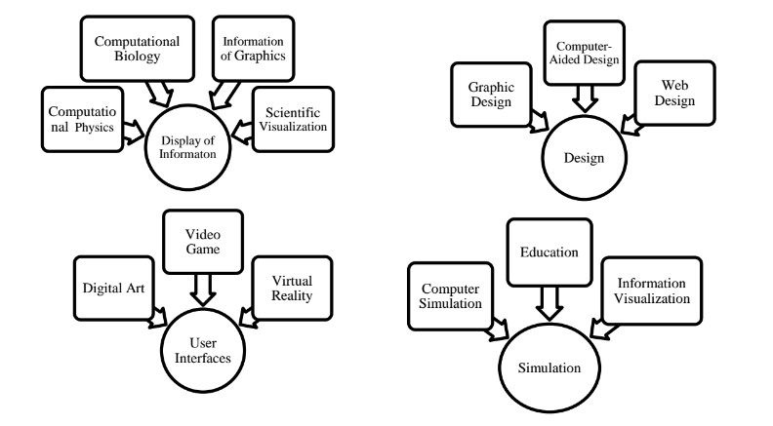
Figure: Application of Computer Graphics

- Differentiate between raster graphics and vector graphics
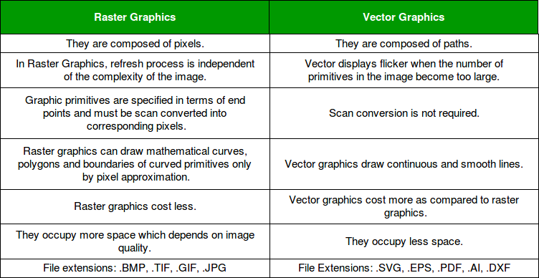
©Explain how resolution affects the color display of a monitor.
I can’t find the answer of this question
The screen creates the image you see by changing the colours of these tiny square elements. The screen resolution tells you how many pixels your screen can display horizontally and vertically. It's written in the form 1,920 x 1,080. In this example, the screen can show 1,920 pixels horizontally, and 1,080 vertically.
6(c) Why TCP is not suitable in real time multimedia transmission?
TCP is not suitable for real-time applications as the retransmissions can lead to high delay and cause delay jitter, which significantly degrades the quality. In addition, it does not support multicast. Also, congestion control mechanisms, namely slow start, are not suitable for audio or video media transmission.
8(a) What is multimedia project?
A multimedia project requires many elements to be brought together and integrated. The stages of collecting and selecting multimedia content, coordinating its transfer or delivery, and its editing and verification are time consuming.
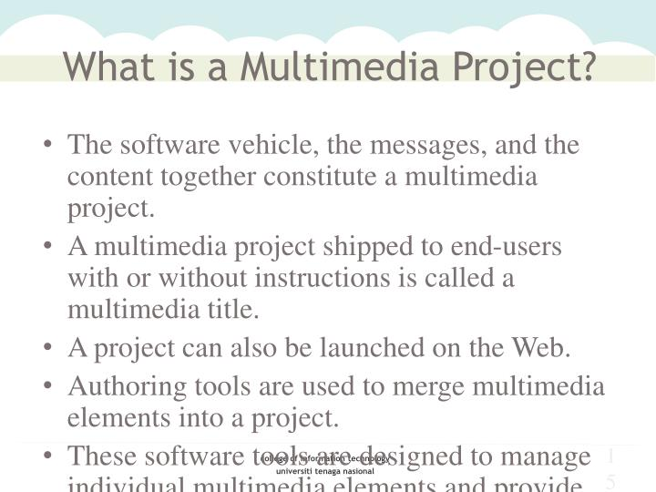
(b)Discuss about the various process involved in multimedia project planning and costing.
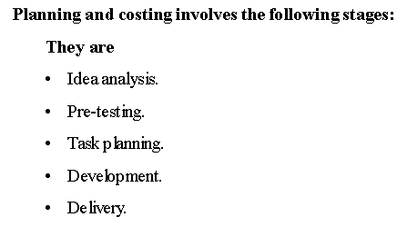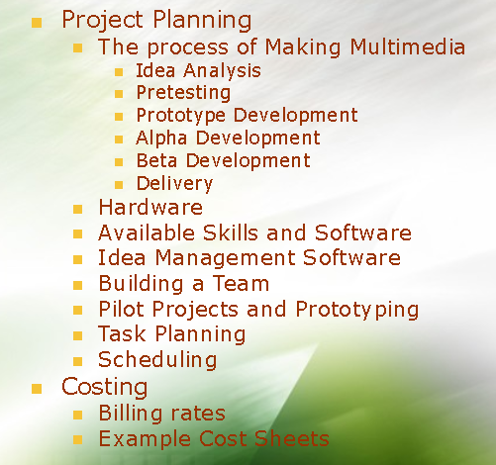

2015
5(a)What are the limitations of LZW compression
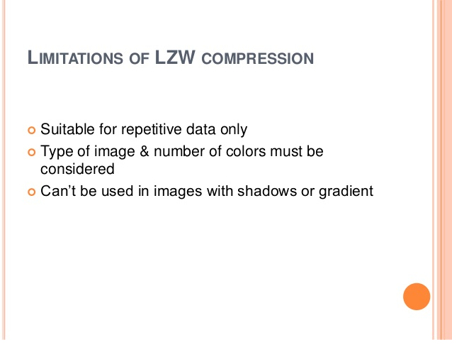
(b)What are the advantages adaptive Huffman coding over Huffman coding
Advantage of adaptive Huffman coding
It saves the time because it does not need to scan the whole string for constructing the first tree. It also saves the time while constructing trees e.g. it needs only one symbol for constructing the first tree unlike in adaptive Huffman requires all different symbols to construct the tree.

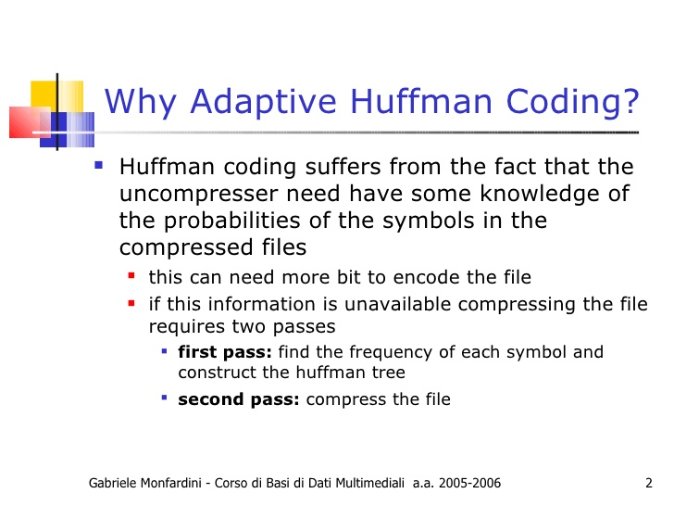
© Which type of protocol between TCP and RTP is used in multimedia transmission? Why?
TCP and UDP are two most commonly used transport protocols on the Internet. TCP provides a connection-oriented and reliable flow between two hosts, while UDP provides a connectionless but unreliable datagram service over the network. UDP was chosen as the target transport protocol for RTP because of two reasons.

7(b)Describe the design issue of RTP in multimedia transmission.
I can’t find this answer.
RTP is designed for end-to-end, real-time transfer of streaming media. The protocol provides facilities for jitter compensation and detection of packet loss and out-of-order delivery, which are common especially during UDP transmissions on an IP network.
8(b)Broadcast schemes for video on demand
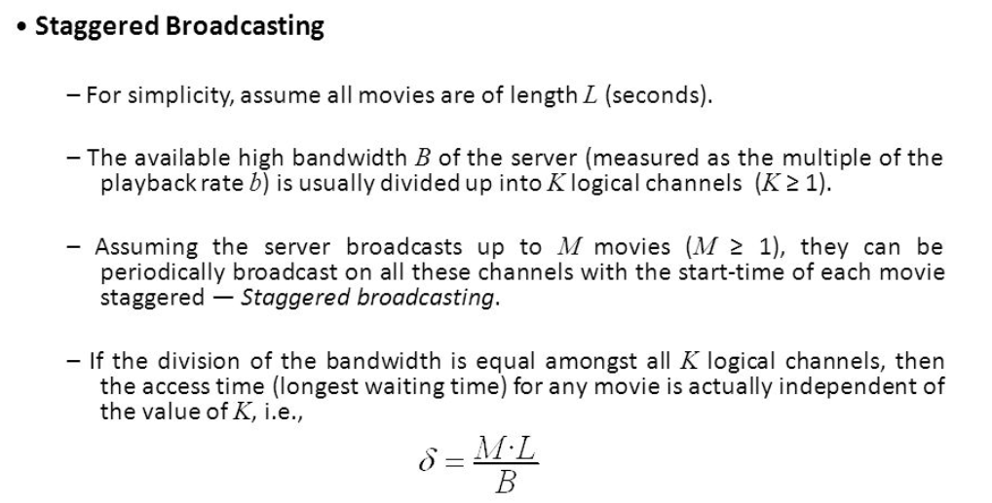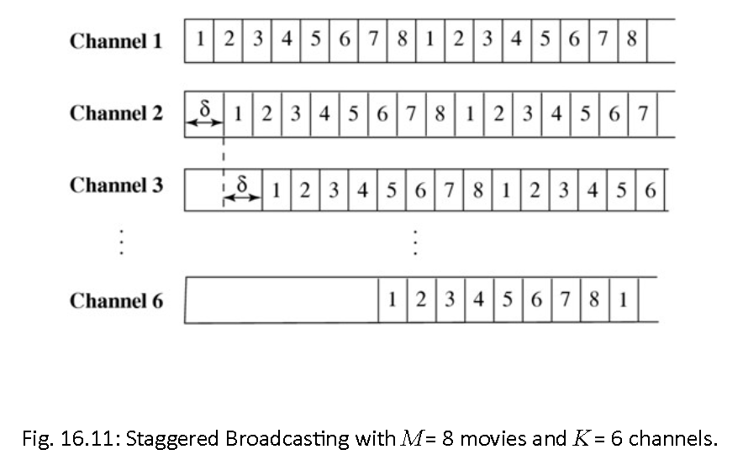

©Video conferencing
Videoconferencing (or video conference) means to conduct a conference between two or more participants at different sites by using computer networks to transmit audio and video data. ... Each participant has a video camera, microphone, and speakers mounted on his or her computer.

Video conferencing is a technology that allows users in different locations to hold face-to-face meetings without having to move to a single location together. ... Uses for video conferencing include holding routine meetings, negotiating business deals, and interviewing job candidates.
In Video Conferencing Software. Video conferencing software is a tool used by two parties to communicate via video and audio using an Internet connection. It enables the parties to initiate and conduct live conferences and remote meetings by transmitting audio, video, and text.
- Voice over IP
Voice over IP refers to the transmission of voice traffic over internet-based networks instead of the traditional PSTN (Public Switched Telephone Network) telephone networks. ... This way, voice over IP can facilitate the addition of telephone lines to businesses without the need for additional physical lines.
VoIP is the technology that converts your voice into a digital signal, allowing you to make a call directly from a computer, a VoIP phone, or other data-driven devices. ... You may also hear it referred to as IP telephony, internet telephony, broadband telephony, or broadband phone service.

As stated above, VoIP systems allow users to choose their hardware. Traditional phones, IP phones, computers and smartphones can now be used to make calls, and so phone calls are no longer restricted to a single device. ... For this reason, VoIP is an important step forward in telephony.

